1. This question is about atomic spectra and energy levels.
Diagram 1 below shows part of the emission line spectrum of atomic hydrogen. The wavelengths of the principal lines in the visible region of the spectrum are shown.
Diagram 2 shows some of the principal energy levels of atomic hydrogen.
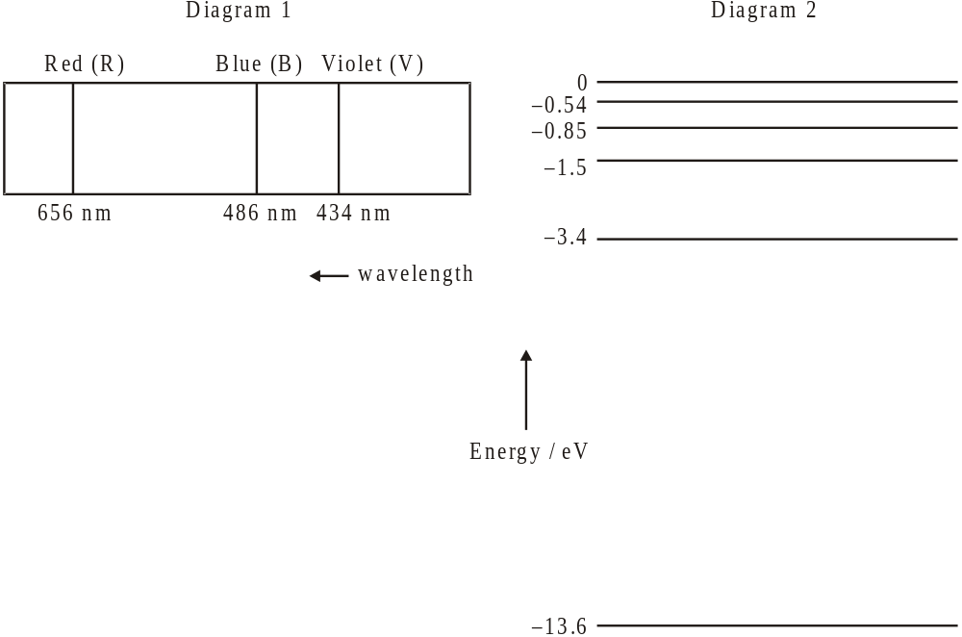
R
B

(a) Name the spectral series shown in diagram 1.
..................................................................................................................................... (1)
(b) Show, by calculation, that the energy of a photon of red light of wavelength 656 nm is 1.9 eV.
E= hc/ lambda E= 1,6022 x 10^-19 x 3.00 x 10⁸ / 656 x 10^-9= 7.32 x 10^-5 J
.....................................................................................................................................
.....................................................................................................................................
(3)
(b) On diagram 2, draw arrows to represent
(i) the electron transition that gives rise to the red line (label this arrow R).
(1)
(ii) a possible electron transition that gives rise to the blue line (label this arrow B).
(1)
(Total 6 marks)

2. This question is about the radioactive decay of potassium-40.
A nucleus of the nuclide K (potassium-40) decays to a stable nucleus of the nuclide Ar (argon-40).
(a) State the names of the two particles emitted in this decay.
K= Ar+ e
(2)

(b) A sample of the isotope potassium-40 initially contains 1.5 × 1016 atoms. On average, 16 nuclei in this sample of the isotope undergo radioactive decay every minute.
Deduce that the decay constant for potassium-40 is 1.8 × 10−17 s−1.
.....................................................................................................................................
.....................................................................................................................................
.....................................................................................................................................
.....................................................................................................................................
(3)

(c) Determine the half-life of potassium-40.
Ln(2)/1,8x10^-17=3.85x10^16s
.....................................................................................................................................
(1)
(Total 6 marks)

3. This question is about particle physics.
A neutron can decay into a proton, an electron and an antineutrino according to the reaction
n → p + e +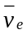.
(a) Deduce the value of the electric charge of the antineutrino.
.....................................................................................................................................
(1)
(b) State whether a proton is a baryon or a lepton.
.....................................................................................................................................
(1)

(b) State the name of the fundamental interaction (force) that is responsible for this decay.
(1)
.....................................................................................................................................

(c) State how an antineutrino differs from a neutrino.
Antineutrino has opposite quantum numbers.
(1)
(Total 4 marks)

4. Nuclear binding energy and nuclear decay
(a) State what is meant by a nucleon, giving an example of two nucleons.
...................................................................................................................................
...................................................................................................................................
...................................................................................................................................
(2)
(b) Explain what a nucleon is made of and what force holds it together. Include a description of the exchange particle that mediates the interaction between nucleons.
...................................................................................................................................
...................................................................................................................................
...................................................................................................................................
(2)
(c) Define what is meant by the mass defect of a nucleus.
...................................................................................................................................
...................................................................................................................................
...................................................................................................................................
(1)
(c) Define what is meant by the binding energy of a nucleus.
...................................................................................................................................
...................................................................................................................................
...................................................................................................................................
(1)

The graph below shows the variation with nucleon (mass) number of the binding energy per nucleon.
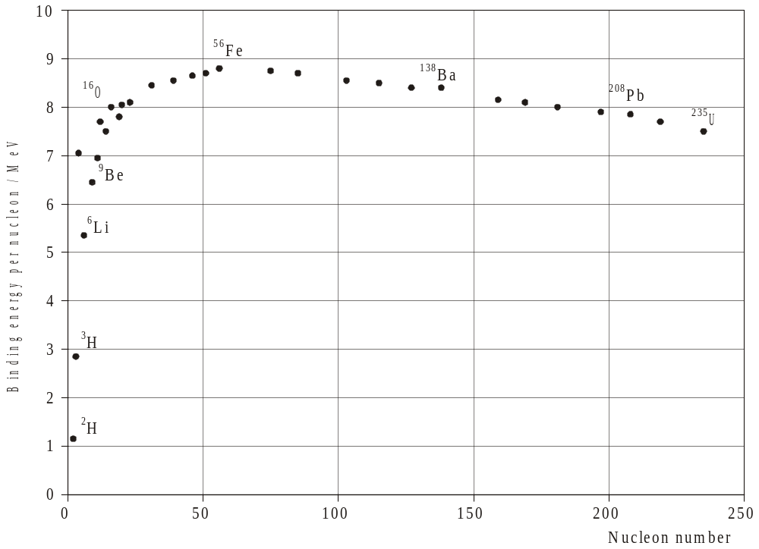
(c) Use the graph to explain why energy can be released in both the fission and the fusion processes.
The binding energy per nucleon can be increased by increasing or decreasing the nucleon number. U- 235 can become Fe- 56 and H- 2 cam do the same inside a star, for example.
...................................................................................................................................
...................................................................................................................................
(3)
(c) Use the graph to explain why there is an abundance of iron (Fe) in the universe.
...................................................................................................................................
...................................................................................................................................
...................................................................................................................................
...................................................................................................................................
...................................................................................................................................
(2)

(d) A sample of carbon-11 has an initial mass of 4.0 × 10–15 kg. Carbon-11 has a half-life of approximately 20 minutes. Calculate the mass of carbon-11 remaining after one hour has elapsed.
...................................................................................................................................
...................................................................................................................................
...................................................................................................................................
(2)

(e) Uranium-238, 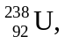 undergoes α-decay to form an isotope of thorium. Write down the nuclear equation for this decay.
Uranium- 238= Thorium- 237+positron
...................................................................................................................................
...................................................................................................................................
(2)
(Total 11 marks)

5. This question is about a proton.
The proton is made out of three quarks.
(a) Explain why the three quarks in the proton do not violate the Pauli exclusion principle.
No 2 fermions exist in the same identical energy quantum space.
(2)

(b) Quarks have spin 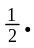Explain how it is possible for the proton to also have spin
Two up quarks have to have opposite spin, so down quark makes the proton to have ½ spin.
(2)
(Total 4 marks)

6. Which one of the following correctly gives the number of electrons, protons and neutrons in a neutral atom of the nuclide 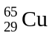?
 | Number of electrons | Number of protons | Number of neutrons
A. | 65 | 29 | 36
B. | 36 | 36 | 29
C. | 29 | 29 | 65
D. | 29 | 29 | 36
(1)

7. The unified mass unit is defined as
A. the mass of one neutral atom of C.
B. 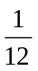 of the mass of one neutral atom of C.
C. of the mass of one neutral atom of C.
D. the mass of the nucleus of C.
(1)

8. Which of the following provides evidence for the existence of atomic energy levels?
A. The absorption line spectra of gases
B. The existence of isotopes of elements
C. Energy release during fission reactions
D. The scattering of α -particles by a thin metal film
(1)

